ASSIGNMENT

THANVI YADAV SIRLA

KINDS OF NATURAL DISASTERS

Description: a scenic view of an island under destruction by the natural disasters.

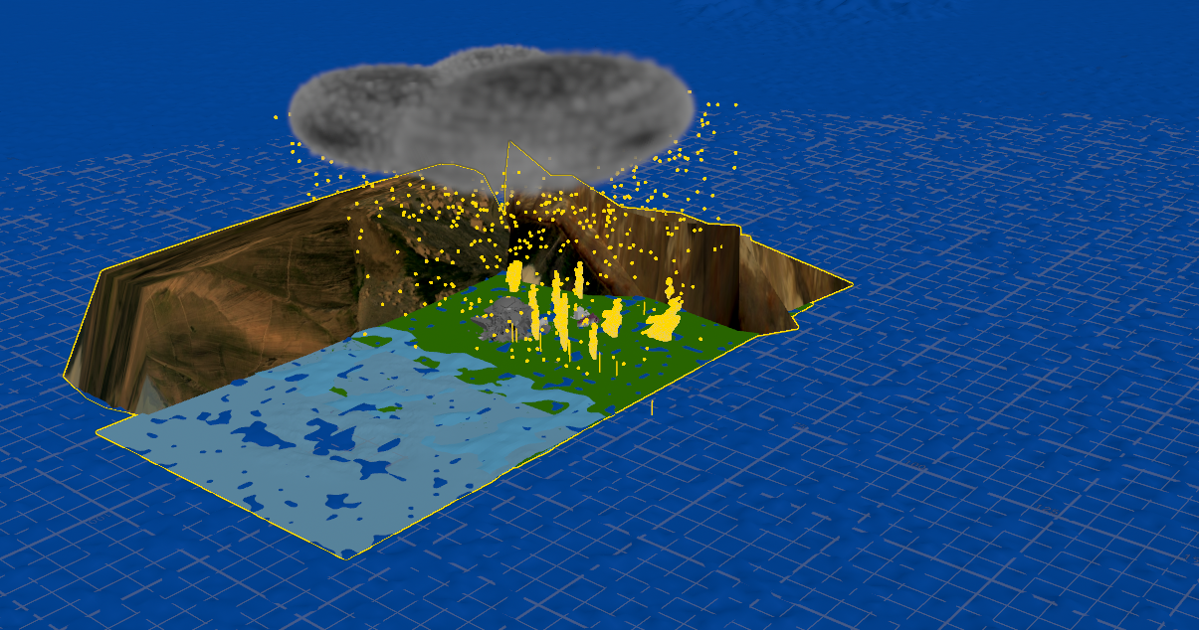

CHARACTERS IN THE PROJECT

* LAND
* WATER
* CLOUDS
* MOUNTAINS
* TREES
* BUILDINGS
* ASTEROID
* FIRE
* RAIN
* TERRAIN

TERRAIN: ISLAND

* We use the terrain island node which is the procedural node. This creates a realistic-looking island terrain.
* It has nodes like heightfield-remap, distort, clip, noise, angle, slump, level clear, set water level and erode nodes in-built in its geometry node.
* In my project I have continued with the default parameters of the above nodes
* Select the terrain FX in the navigation bar in that select the terrain island.
* The terrain_islands node is created in the network pane, and we can also see the terrain island when blue flagged in the scene view.
* This creates more realistic scene of an island to my project.

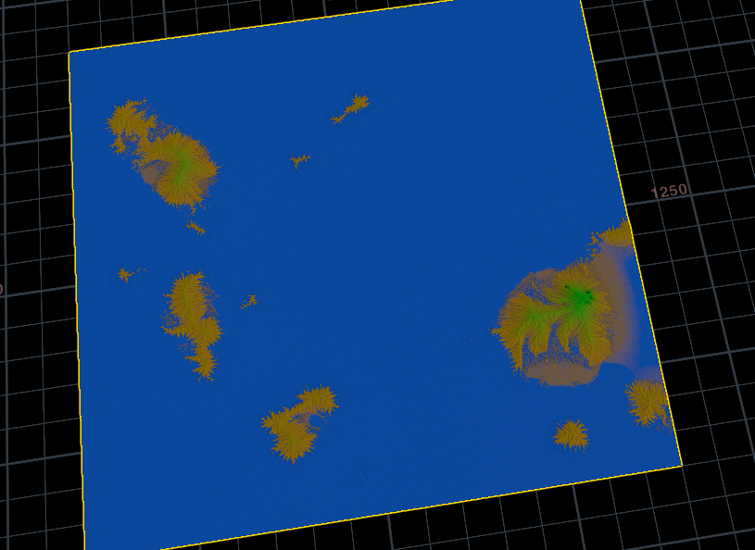

LAND

Nodes used: Grid and color.

* Creating a land using grid node.
* In the object level create geometry node and double click to enter the geometry level.
* 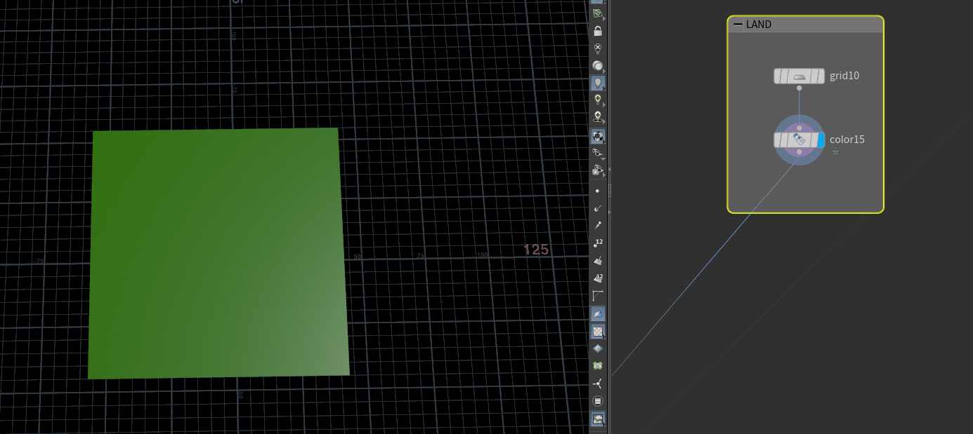I am creating sticky notes for organization since it makes my work easier and understandable.
* Right click and select the grid node.
* In the grid node,
  + I have given the size parameter to x=100 and y=100.
  + Centre: x=-7, y=0, z=-5.
  + Rows=columns=2
* In the color node,
  + I choose green to specify the land.
  + The color type to constant.

WATER:

Nodes used: Grid, oceanwaves, ocean, spectrum, oceanevaluate and color node for a still ocean and waves.

* I created a sticky notes.
* Then created a grid node: in the grid node I specified the size parameter to 70 and 60.
* 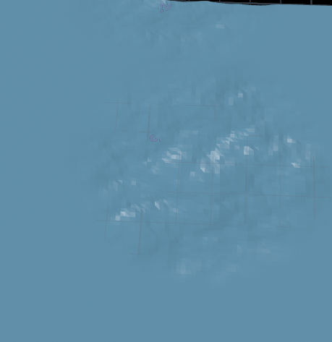Then specified centre for x=7.9, y=0, z=55.
* Create an oceanwave node and specify parameters of the number of waves, size, separation of waves and distance.
* Create an oceanspectrum node and specify parameters depth, gravity and time scale.
* Create an ocean evaluate node to set the time of wave.
* Create a color node, connect to ocean evaluate. In color node select a blue shade which is more near to the ocean color.
* Blueflag the color node to see the ocean.

OCEAN FLOOD:

* 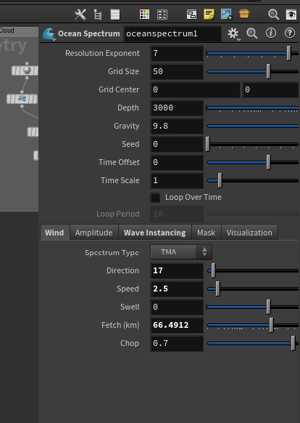Nodes used: grid, oceanspectrum, ocean evaluate, color node.
* In the grid, select the size and edit it to x=70 and y= $F -110.
* In the ocean spectrum select the wind attribute, set the direction, speed, fetch and chop parameters as shown in the image.
* In the ocean evaluate node set the down sample to 2, depth division and maxdepth as 20 and 5.5 repectively.
* Create a color node and keep the color similar to still ocean so that they doesn’t look weird together.

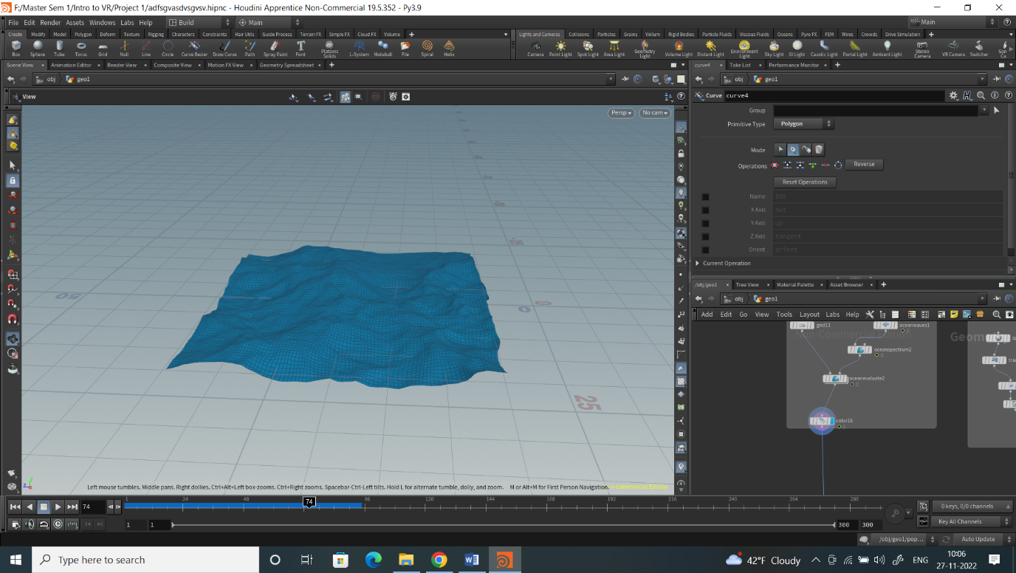

CLOUDS:

Nodes used: sphere, transform, cloud, cloud noise, merge nodes.

* Right Click in the network pane, search for sphere and place it in the network pane.
* In parameter pane sphere node, radius value is (1, 1), rows and columns are 34 and 36 respectively. Uniform scale as required.
* Parameter pane transform node, translate value is (8.11667, 50, 28.953), scale value is (0.6,0.3,0.9) and uniform scale is 10.
* Right Click in the network pane, search for cloud and place it in the network pane.
* Right Click in the network pane, search for cloudnoise and place it in the network pane. In parameter pane of cloudnoise1 node, Amplitude is 0.78, Octaves is 6 and element size is 0.718.
* Connect sphere to transform to cloud1 to cloudnoise1.
* Repeat the step for other 2 clouds and change the values in translate based on the coordinates in scene view of transform node.
* Right Click in the network pane, search for merge and place it in the network pane. And connect cloudnoise1, cloudnoise2, cloudnoise3 to merge node.
* Use polyextrude to increase the distance.
* Use inset and twist parameters.

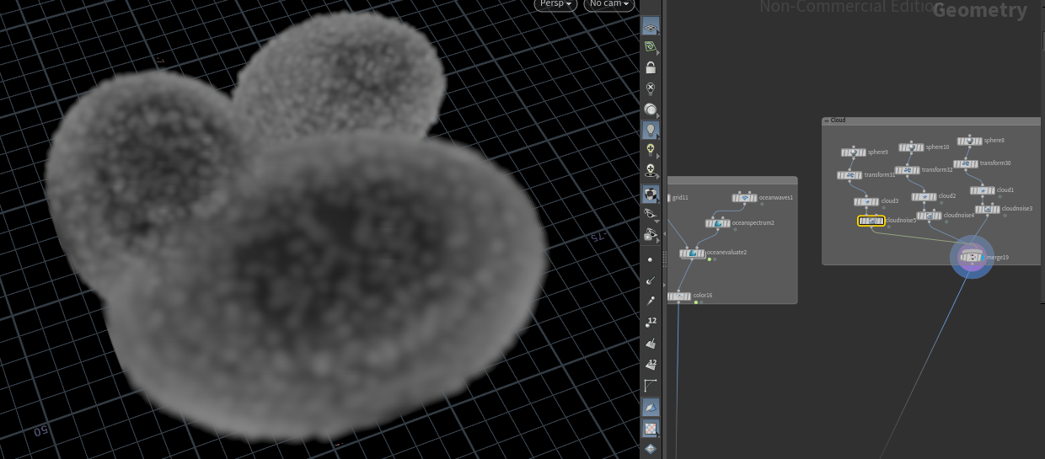

MOUNTAINS:

Nodes used: grid, polyextrude, mountain, color, uvquickshade.

* Create a grid node, then select the parameters such as size, centre and rotation. Change them accordingly.
* Adjust columns and rows, then the rotate parameters.
* Then create a mountain node and set the amplitude to 10.
* Then create a color node.
* Set the color to near brown to depict the mountain.
* Then create a uvquickshade node.
* I have downloaded a mountain image from the internet and browsed for the image in uvquickshade.
* Now the mountain is surmounted with the image.
* Repeat this step for another rmountain.
* 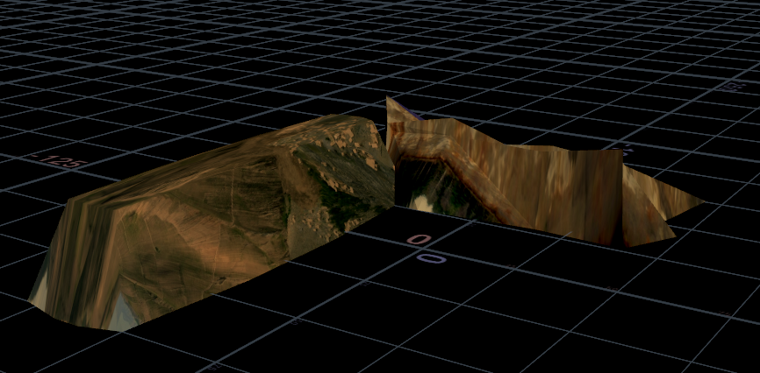 Make sure that the other mounatain is in not on the same side of the first mountain.

TREES:

Nodes used: Line, transform, copy and transform, merge nodes.

* Create a line node.
* Specify the length, direction. I preferred the length of 1.64.
* Create a transform node.
* Translate, rotate and scale parameters to scale the trees.
* Create a copy and transform node, use the uniform scale parameter and translate parameter.
* We can also adjust the number of copies.
* Repeat this three times to create other trees.
* Connect them with the merge node.

TREES AND FIRE:

Nodes used: line, transform, popnet, color, merge.

* Right Click in the network pane, search for line and place it in the network pane. In parameter plane of line2 node, length value is 1.95 and points are 2 in value.
* Repeat steps of line.
* Right Click in the network pane, search for popnet and place it in the network pane. Get into the popnet and place windforce node form tab menu, place it between popsolver and output. In parameter pane of windforce1 node, scale force is 28 and activation value is 4.96.
* Right Click in the network pane, search for color and place it in the network pane. In parameter pane of color1 node, Attribute should be velocity, and color should be yellow to red.

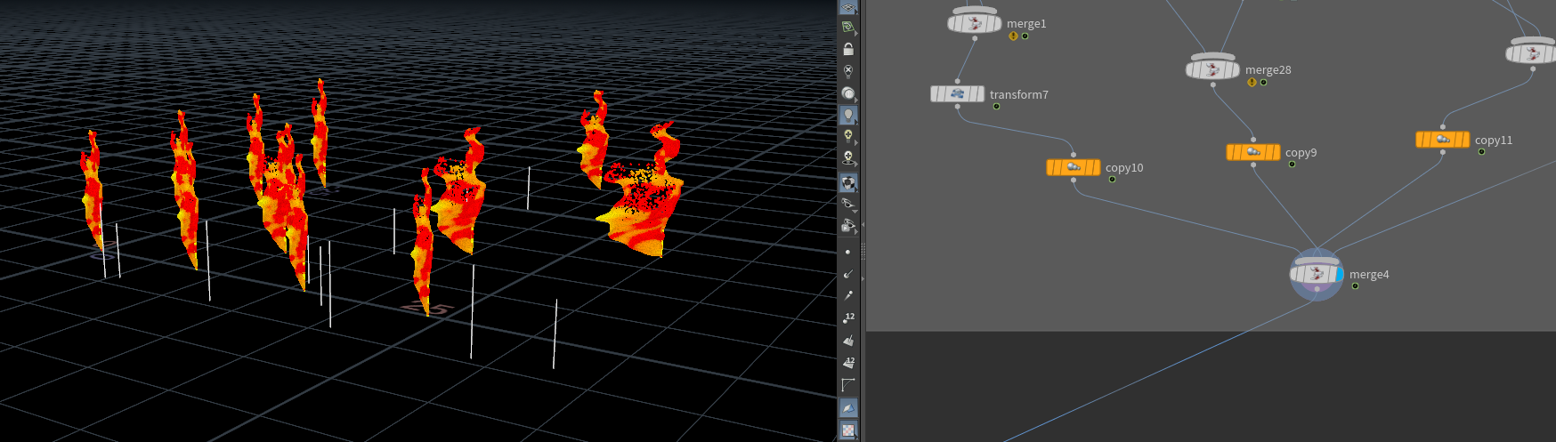

* Right Click in the network pane, search for merge and place it in the network pane. Connect line2 to merge1, line7 to popnet to color1 to merge1.
* Right Click in the network pane, search for transform and place it in the network pane. In parameter pane of transform7 node, translate value is (8.27599, 0, -9.04432)
* Connect merge1 to transform7.
* .Repeat steps for other 3 tree fire and change the values in transform based on the coordinates in screen view of transform node.
* Right Click in the network pane, search for merge and place it in the network pane. Connect transform7, transform2, transform3 to merge.
* Blue flag the merge node to see the fire.
* We can use the animation bar to animate.

BUILDINGS:

Nodes used: for house: grid, polyextrude, transform, copy and transform, merge, color, rbdbulletsolver and rbdmaterial fracture.

* Right Click in the network pane, search for grid and place it in the network pane. In parameter pane of grid node, size value is (1,1) and rows and columns are 6 and 5 respectively.
* Right Click in the network pane, search for polyextrude and place it in the network pane. In parameter pane of polyextrude node, distance value is 0.003, Insert value is 0.037.
* Right Click in the network pane, search for transform and place it in the network pane. In parameter pane of transform node, translate value is (0, 0.5, 1) and rotation is (90,0,0).
* Connect grid to polyextrude to transform.
* Right Click in the network pane, search for grid and place it in the network pane. In parameter pane of grid node, size value is (1,1) and rows and columns are 6 and 5 respectively.
* Right Click in the network pane, search for polyextrude and place it in the network pane. In parameter pane of polyextrude6 node, distance value is 0.003, Insert value is 0.037.
* Right Click in the network pane, search for transform and place it in the network pane. In parameter pane of transform node, translate value is (0.5, 0.5, 0) and rotation is (0,0,-90).
* Connect grid to polyextrude to transform.
* Right Click in the network pane, search for grid and place it in the network pane. In parameter pane of grid4 node, size value is (1,2) and rows and columns are 2 respectively.
* Right Click in the network pane, search for polyextrude and place it in the network pane. In parameter pane of polyextrude5 node, distance value is 1.5.
* Right Click in the network pane, search for polyextrude and place it in the network pane. In parameter pane of polyextrude node, distance value is 1, and now select the group node and set the base range to (0). Now, tick the transform extruded front and scale it to (0,0,1).
* Right click in the network pane and type color6 node and place in the network pane, In group place give number (5-8). Color range (0.2,0.2,0.2), in class parameter change to primitive.
* Connect grid4 to polyextrude5 to polyextrude to color.
* Right Click in the network pane, search for merge and place it in the network pane. Connect transform, transform, color to merge.
* Right Click in the network pane, search for transform and place it in the network pane. In parameter pane of transform node, translate value is (5,0,-5).
* Repeat this steps for other house.
* Use the copy and transform node to create many houses4.
* Use rotation and number of copy parameters to customize.

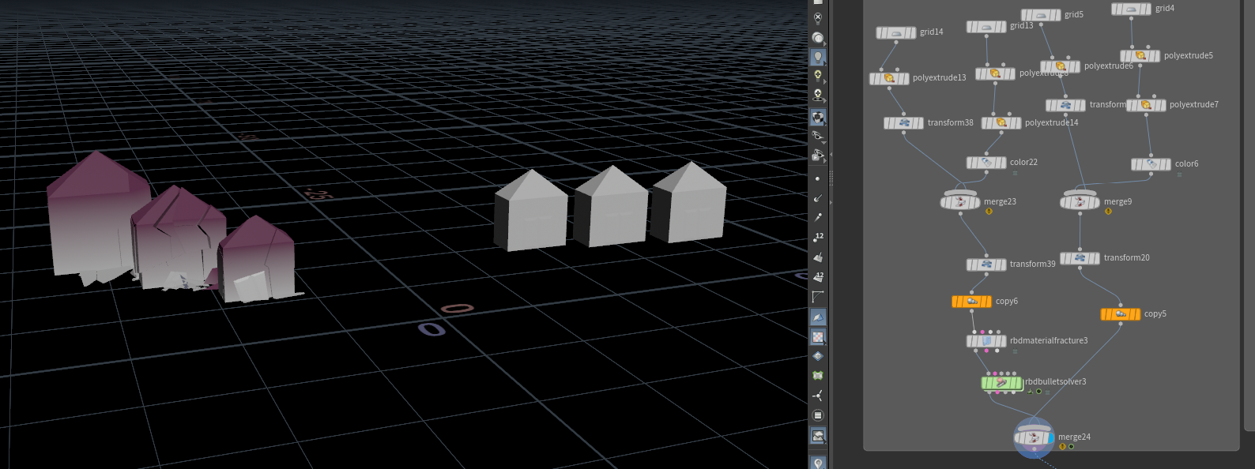

FOR DESTRUCTION:

* (Repeat the steps of house1 Character to House 1 destroy Character)
* Right Click in the network pane, search for rbdmaterialfracture and place it in the network pane. In parameter pane of rbdmaterialfracture1 node, tick the Fracture per piece and enable chipping, search radius is 1.6, strength variance is 0.42, primary strength value is 400, and chipping glue strength is 100.
* Right Click in the network pane, search for rbdbulletsolver and place it in the network pane. In parameter pane of rbdbulletsolver1 node, start frame value is 105, in ground Collision form ground type should be changed to Ground Plane, time scale is 1, bullet substeps and constraint iterations is 10 respectively.
* Right Click in the network pane, search for group and place it in the network pane. In parameter pane of group1 node, size is (2.28295, 1.85269, 4.35065) and center value is (0.398907, 0.998789, 2.21394).
* Right Click in the network pane, search for pointvelocity and place it in the network pane. In parameter pane of pointvelocity1 node, group input is group1 and frame sample 2.79.
* Right Click in the network pane, search for transform and place it in the network pane. In parameter pane of transform19 node, translate value is (5,0,-5).
* Connect merge7 to rbdmaterialfracture1,output1, out2 are connect to input1, input2 of rbdbulletsolver1, output3 is connect to group1 to pointvelocity1 to input3 of rbdbulletsolver1 to transform19.

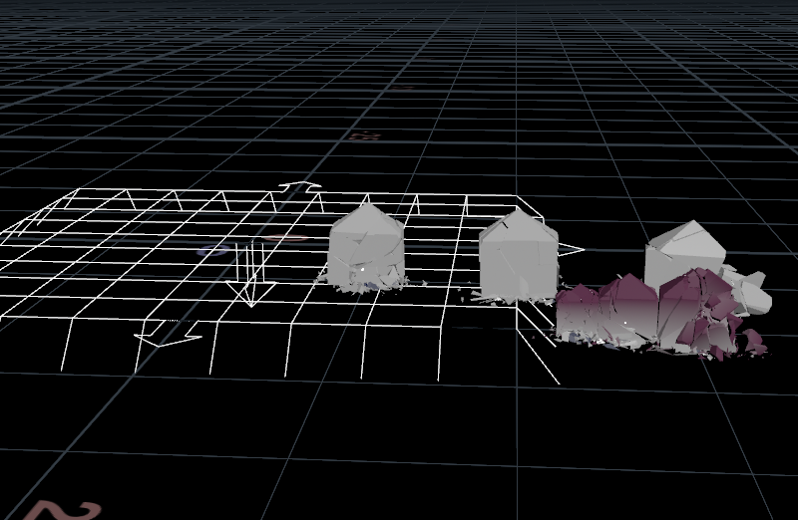

BUILDING WITH HELIPAD:

Nodes used: circle, sphere, grid, font, polyextrude.

* Right Click in the network pane, search for sphere and place it in the network pane. In parameter pane of sphere4 node, Radius is (0.5, 0.5, 0.5) center is (0, 5, 0). Rows and columns are 13 and 24 respectively.
* Right Click in the network pane, search for grid and place it in the network pane. In parameter pane of grid8 node, size value is (2,3). Rows and columns are 6 respectively.
* Right Click in the network pane, search for polyextrude11 and place it in the network pane. In parameter pane of polyextrude11 node, group input is 0-8 10-13 15-18 20-24, distance value is 5 and division are 14.
* Right Click in the network pane, search for polyextrude12 and place it in the network pane. In parameter pane of polyextrude12 node, group input is 3 7 20 24, distance value is 1.5 and division are 1.
* Right Click in the network pane, search for merge and place it in the network pane. Connect sphere4 to merge12, grid8 to polyextrude11 to polyextrude12 to merge12.
* Right Click in the network pane, search for color and place it in the network pane. In parameter pane of color20 node, rgb(0.333, 0.333, 0.333).
* Creating a helipad on the building. Use the circle node.
* Create a color node and the font.
* Keep the circle on the sphere on the top of the building.
* Use font to keep the H on the helipad.
* I choose the pista color to the sphere and cream to the building.
* An orange shade to the helipad.
* Use the merge node to see the building completely by connecting all the nodes.

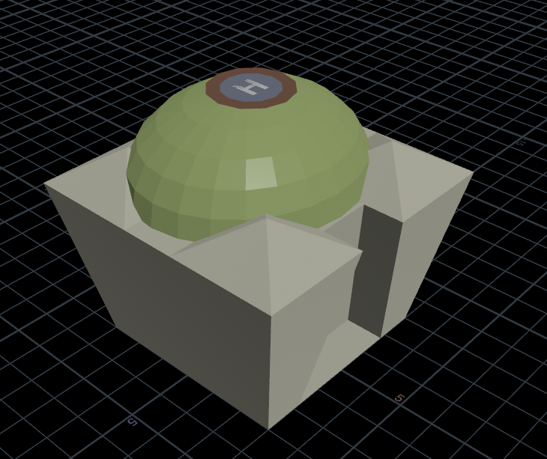

FOR DESTRUCTION:

Nodes used: circle, sphere, rbdmaterialfracture, rbdbulletsolver, color, merge, font, polyextrude.

* (Repeat the steps of building Character to building destroy)
* Right Click in the network pane, search for rbdmaterialfracture and place it in the network pane. In parameter pane of rbdmaterialfracture2 node, tick the Fracture per piece and enable chipping, search radius is 1.6, strength variance is 0.42, primary strength value is 400, and chipping glue strength is 100.
* 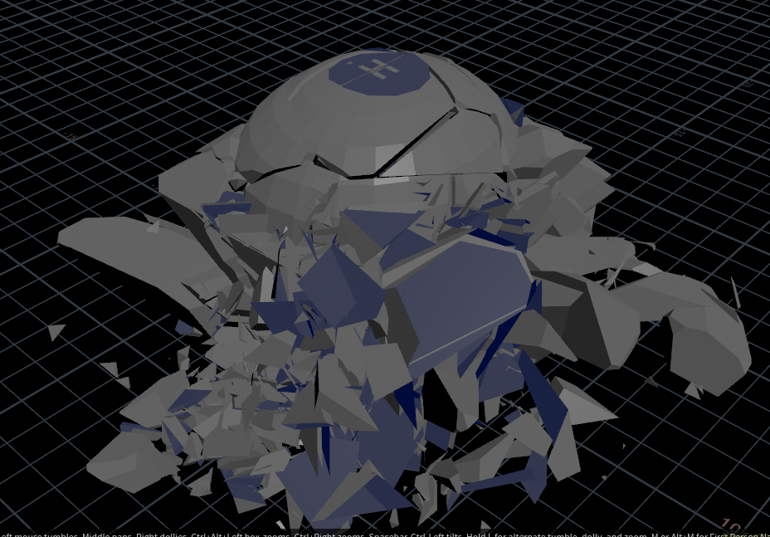Right Click in the network pane, search for rbdbulletsolver and place it in the network pane. In parameter pane of rbdbulletsolver2 node, start frame value is 100, in ground Collision form ground type should be changed to Ground Plane, time scale is 1, bullet substeps and constraint iterations is 10 respectively.
* Right Click in the network pane, search for group and place it in the network pane. In parameter pane of group2 node, size is (6.36116, 1.85269, 7.26742) and center value is (2.43801, 0.998789, 0.755557).
* Right Click in the network pane, search for point velocity and place it in the network pane. In parameter pane of pointvelocity2 node, group input is group1 and frame sample 2.79.
* Right Click in the network pane, search for color and place it in the network pane. In parameter pane of color21 node, rgb(0.333, 0.333, 0.333).
* Connect merge10 to rbdmaterialfracture2,output1, out2 are connect to input1, input2 of rbdbulletsolver2, output3 is connect to group2 to pointvelocity2 to input3 of rbdbulletsolver2 to color21.

ASTEROID:

Nodes used: sphere mountain, transform, color, popnet.

* Right Click in the network pane, search for sphere and place it in the network pane. In parameter pane of sphere1 node, primitive type is polygon, Radius is (0.4, 0.4, 0.6) frequency is 50.
* Right Click in the network pane, search for mountain and place it in the network pane. In parameter pane of mountain1 node, amplitude value is 0.25, element size is 0.6.
* Right Click in the network pane, search for transform and place it in the network pane. In parameter pane of transform10 node, rotate value is (165, 0, 0)
* Right Click in the network pane, search for transform and place it in the network pane. In parameter pane of transform9 node, rotate value is (0, 0, $F*5)
* Right Click in the network pane, search for transform and place it in the network pane. In parameter pane of transform4 node, translate value is (0, 50, 60) and uniform scale is 2.19
* Right Click in the network pane, search for transform and place it in the network pane. In parameter pane of transform1 node, translate value is (0, $F/2*-1, ch("ty")*1.5).
* Right Click in the network pane, search for pop network and place it in the network pane. Get into the popnet3 and place windforce node form tab menu, place it between popsolver and output.
* In parameter pane of windforce1 node, velocity value is (0 ,1, 0) scale force is 28, Activation is 5.
* Go back to geometry view in network pane.

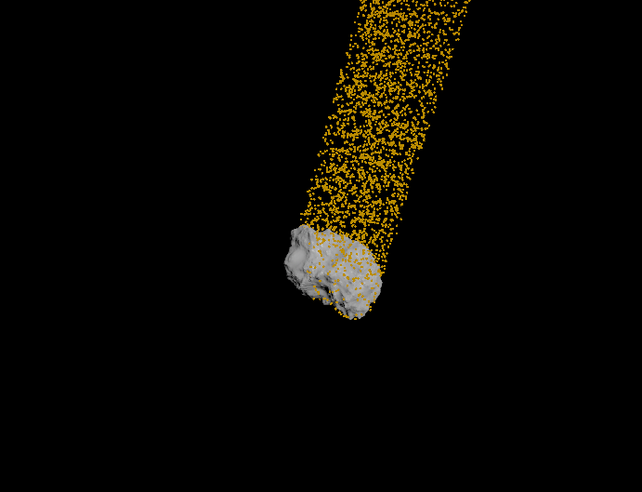

* Right Click in the network pane, search for color and place it in the network pane. In parameter pane of color4 node, color type is Ramp from Attribute, Attribute is should be age, Range is (0, 2) and Attribute Ramp should be color in yellow, red and black.
* Right Click in the network pane, search for sphere and place it in the network pane. In parameter pane of sphere2 node, primitive type is polygon, Radius is (0.4, 0.4, 0.6) frequency is 50.
* Right Click in the network pane, search for mountain and place it in the network pane. In parameter pane of mountain2 node, amplitude value is 0.25, element size is 0.6.
* Right Click in the network pane, search for transform and place it in the network pane. In parameter pane of transform11 node, rotate value is (165, 0, 0)
* Right Click in the network pane, search for transform and place it in the network pane. In parameter pane of transform6 node, rotate value is (0, 0, $F*5)
* Right Click in the network pane, search for transform and place it in the network pane. In parameter pane of transform8 node, translate value is (0, 50, 60) and uniform scale is 2.19
* Right Click in the network pane, search for transform and place it in the network pane. In parameter pane of transform5 node, translate value is (0, $F/2*-1, ch("ty")*1.5).
* Right Click in the network pane, search for merge and place it in the network pane. Connect sphere1 to mountain1 to transform10 to transform9 to transform4 to transform1 to popnet3 to color4 to merge16, sphere2 to mountain2 to transform11 to transform6 to transform8 to transform5 to merge16.

ASTEROID LAND:

Nodes used: sphere, mountain, transform, color,popnet.

* Right Click in the network pane, search for sphere and place it in the network pane. In parameter pane of sphere5 node, primitive type is polygon, Radius is (0.4, 0.4, 0.6) frequency is 50.
* Right Click in the network pane, search for mountain and place it in the network pane. In parameter pane of mountain4 node, amplitude value is 0.25, element size is 0.6.
* Right Click in the network pane, search for pop network and place it in the network pane. Get into the popnet4 and place windforce node form tab menu, place it between popsolver and output.
* In parameter pane of windforce1 node, velocity value is (0 ,1, 0) scale force is 28, Activation is 5.
* Go back to geometry view in network pane.
* Right Click in the network pane, search for color and place it in the network pane. In parameter pane of color13 node, color type is Ramp from Attribute, Attribute is should be age, Range is (0, 2) and Attribute Ramp should be color in yellow, red and black.
* Right Click in the network pane, search for sphere and place it in the network pane. In parameter pane of sphere6 node, primitive type is polygon, Radius is (0.4, 0.4, 0.6) frequency is 50.
* Right Click in the network pane, search for mountain and place it in the network pane. In parameter pane of mountain5 node, amplitude value is 0.25, element size is 0.6.
* Right Click in the network pane, search for merge and place it in the network pane. Connect sphere5 to mountain4 to popnet4 to color13 to merge17, sphere6 to mountain5 to merge17.
* Right Click in the network pane, search for transform and place it in the network pane. In parameter pane of transform36 node, translate value is (-1.16616, 0, -15.0423)

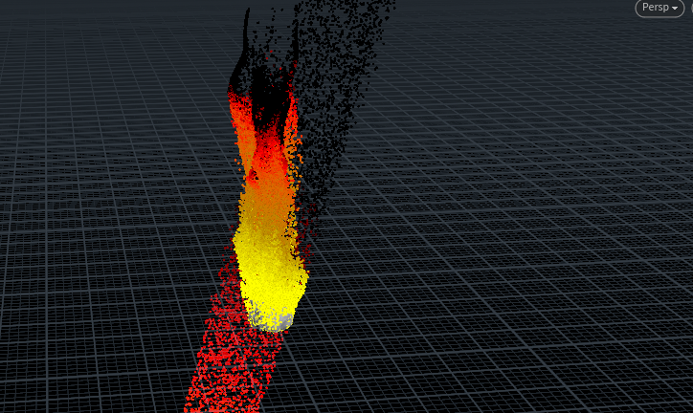

RAIN:

Nodes used: grid, popnet, color.

* Right Click in the network pane, search for grid and place it in the network pane.
* In parameter pane of grid 9 node, size value is (70, 70), center value is (0, 50,0), and rows and columns are 10 respectively.
* Right Click in the network pane, search for pop network and place it in the network pane. Get into the popnet5 and place gravity node form tab menu, place it between popsolver and output.
* In parameter pane of gravity1 node, force value is (0, -9.80665, -0.5).
* In parameter pane of source_first_input node, Impulse count value is 10, const. Birth rate 50, max point pre frame is 60, speed is 0.45 and life expectancy is 3.4.
* Go back to geometry view in network pane.
* Right Click in the network pane, search for color and place it in the network pane. In parameter pane color14 node, rbg value is (1, 1, 1).
* Connect grid9 to popnet5 to color14.
* Keep the rain in a way that the rain should look like it is falling from the clouds.
* 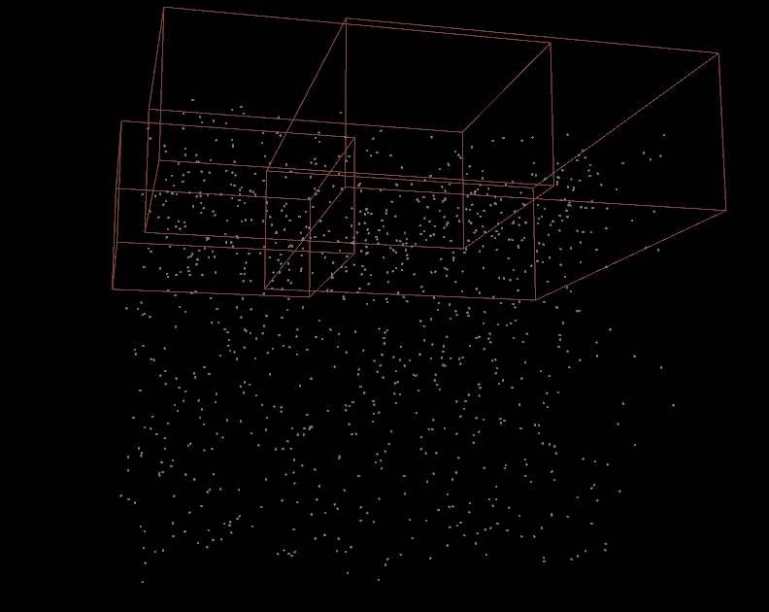The clouds which look so dangerous, so the rain drop count should also be much.

NAME:

Nodes used: font, color, transform.

* Right Click in the network pane, search for font and place it in the network pane.
* In parameter pane, Type name in TEXT as THANVI YADAV SIRLA horizontal alignment change it to (38,0.5, 15).
* Right Click in the network pane, search for transform and place it in the network pane. In parameter pane of transform37 node, scale as (10,9, 8) rotate value is (270, 90, 0).
* Right Click in the network pane, search for color and place it in the network pane. In parameter pane color18 node.
* Connect font1 to transform37 to color18.
* Time scale the font timing using the switch node.
* The name will be visible at the end.

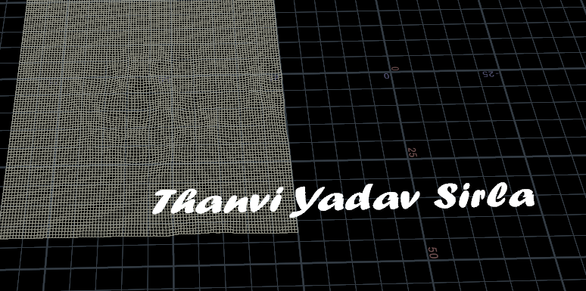

USE OF SWITCH AND NULL NODE:

Switch node switches between multiple geometries in the project.

Null is used as a place holder node.

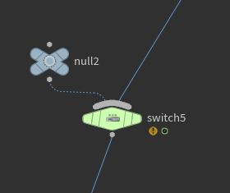

CONNECTING ALL THE NODES:

* Right Click in the network pane, search for merge and place it in the network pane. Connect Asteroid Character, Tree Character is connected to merge5 node.
* Right Click in the network pane, search for switch and place it in the network pane. In parameter pane of switch1 node, switch Input is $F-100. Merge5 and tree fire Character is connected to switch1.
* Right Click in the network pane, search for switch and place it in the network pane. In parameter pane of switch2 node, switch Input is $F-105. House 1 Character and House 1 destroy Character are connected to switch2 node.
* Right Click in the network pane, search for merge and place it in the network pane. Connect switch1 and switch2 to merge8.
* Right Click in the network pane, search for switch and place it in the network pane. In parameter pane of switch3 node, switch Input is $F-100. House 2 Character and House 2 destroy Character are connected to switch3 node.
* Right Click in the network pane, search for merge and place it in the network pane. Connect merge8 and switch3 to merge11.
* Right Click in the network pane, search for null and place it in the network pane.
* Right Click in the network pane, search for merge and place it in the network pane. Connect merge11 and switch4 to merge11.
* Right Click in the network pane, search for null and pTORNODOlace it in the network pane.
* Right Click in the network pane, search for switch and place it in the network pane. In parameter pane of switch5 node, switch Input is $F-100. Null2 and Asteroid Land Character are connected to switch5 node.
* Right Click in the network pane, search for merge and place it in the network pane. Connect merge14 and switch5 to merge18.
* Right Click in the network pane, search for null and place it in the network pane.
* Right Click in the network pane, search for switch and place it in the network pane. In parameter pane of switch6 node, switch Input is $F-100. Null3 and Ocean floods Character are connected to switch6 node.
* Right Click in the network pane, search for merge and place it in the network pane. Connect merge18 and switch6 to merge.
* Right Click in the network pane, search for null and place it in the network pane.
* Right Click in the network pane, search for switch and place it in the network pane. In parameter pane of switch8 node, switch Input is $F-255. Null4 and Font Character are connected to switch8 node.
* Right Click in the network pane, search for merge and place it in the network pane. Connect merge and switch8 to merge.
* Right Click in the network pane, search for merge and place it in the network pane. Connect Ocean Character, Cloud Character, RAIN Character, color15 to merge.

FINAL OUTPUT:

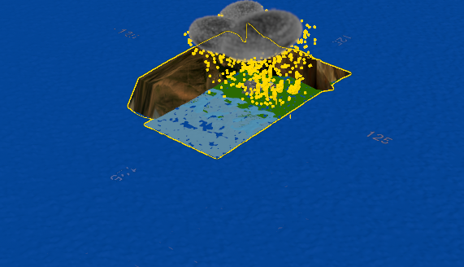

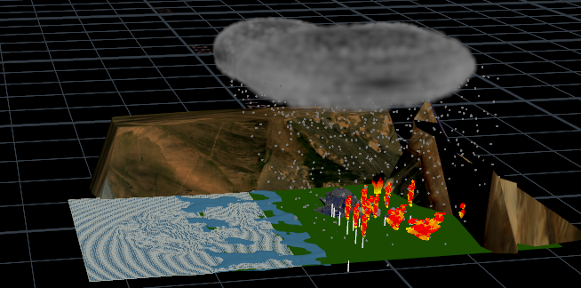 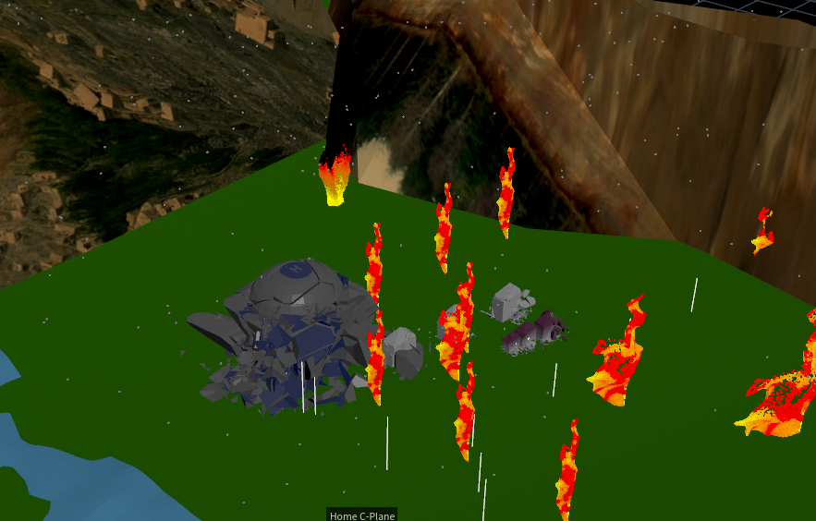

References

<https://www.youtube.com/watch?v=OsKGtFjNCqw&t=91s>

<https://www.sidefx.com/docs/houdini/nodes/sop/rbdmaterialfracture.html>

<https://www.youtube.com/watch?v=tQfoBAJpnDo&t=84s>

<https://www.sidefx.com/docs/houdini/nodes/dop/gravity.html>